PROJECT: Productivity gains from biologically active soil initiated through biochar-activated compost in an avocado orchard.
Project proponent: Warren Catchments Council (Doug Pow - landholder-researcher)
LEGEND
% Proportion of biochar V/V added to topsoil 3.5m
% biochar mixed in top 50cm of row 3.5m wide x 55m per block
C Chicken manure/woody chip mulch
Ratio: 2m³ Chicken manure (50:50 ground wood:manure); m³ course woody chips; m³ old small sawdust
B-A-C Biochar-activated chicken manure/woody chip mulch
Ratio: 2m³ Chicken manure (50:50 ground wood:manure); m³ course woody chips; m³ old small sawdust; m³ biochar
NIL Control with no nutrient rich composting mulch, standard industry practice applied

Each application has a replicate and matched pair (control)
All will receive standard industry practice additional to treatments

Each treatment is repeated for three soil types

Trees are planted 4.5m apart, staked, sprinkler per tree, electronically tagged

Rows are spaced at 9m intervals
Rows deep ripped (60cm), rotary hoed

Planting zone 3.5m biochar (V/V) rotary hoed ie varying heights mounding will result

TREATMENT | SOIL TYPE | CONTROL | TREE #
20% C | RED KARRI LOAM ON CLAY | C | 1
20% C |  | C | 2
20% B-A-C |  | B-A-C | 3
20% B-A-C |  | B-A-C | 4
10% C |  | C | 5
10% C |  | C | 6
10% B-A-C |  | B-A-C | 7
10% B-A-C |  | B-A-C | 8
5% C |  | C | 9
5% C |  | C | 10
5% B-A-C |  | B-A-C | 11
5% B-A-C |  | B-A-C | 12

20% C | RED GRAVELLY KARRI LOAM ON DEEPER CLAY | C | 13
20% C |  | C | 14
20% B-A-C |  | B-A-C | 15
20% B-A-C |  | B-A-C | 16
10% C |  | C | 17
10% C |  | C | 18
10% B-A-C |  | B-A-C | 19
10% B-A-C |  | B-A-C | 20
5% C |  | C | 21
5% C |  | C | 22
5% B-A-C |  | B-A-C | 23
5% B-A-C |  | B-A-C | 24

20% C | BROWN SANDY LOAM ON GRAVEL (NO CLAY <60CM) | C | 25
20% C |  | C | 26
20% B-A-C |  | B-A-C | 27
20% B-A-C |  | B-A-C | 28
10% C |  | C | 29
10% C |  | C | 30
10% B-A-C |  | B-A-C | 31
10% B-A-C |  | B-A-C | 32
5% C |  | C | 33
5% C |  | C | 34
5% B-A-C |  | B-A-C | 35
5% B-A-C |  | B-A-C | 36
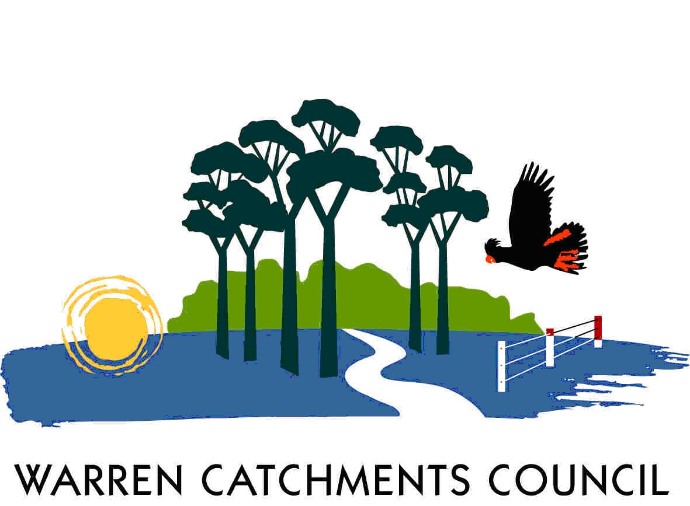

The South West Catchments Council supports this project, through funding from the Australian Government and the Government of Western Australia

