“Productivity gains from biologically active soil initiated through biochar-activated compost in an avocado orchard.”
Avocado field trial conducted at 181 Pipe Clay Gully Rd, Manjimup by Mr Doug Pow and Warren Catchments Council, with funding support from the National Landcare Programme.

Trial Overview:
Hypotheses:

The incorporation of biochar into the rhizosphere of avocados will alter typical Manjimup soils’ physical structure to more closely resemble the andisol soils of their native cultivation, by improving soil drainage and aeration - critical elements in Phytophthora cinnamomi control (a localised avocado industry issue).

The activated-biochar composting mulch will enhance nutrient input efficiencies through its encouragement of mycorrhizal colonisation and biological mineralisation, mobilising plant available nutrients.

a) Research Questions

- How does the proportion of biochar mixed into the top 30 cm of the tree’s planting bed affect soil physical structure, nutrient cycling and mycorrhizal fungi colonisation?

- To what extent does biochar-activated composting mulch improve the growth, health and productive capacity of the avocado?

b) Aim

This project seeks to assess the effects of a range of soil amendments extended over 4 years on:
- Plant growth and vigour
- Plant uptake of nutrients
- Fruit nutrients and quality (testing not currently available commercially)
- Soil health (physical, chemical, biological including mycorrhizal fungi)
- Moisture retention
- Nutrient retention within 0-30cm layer
- Sub-soil acidity
- Disease and pest protection (especially Phytophthora cinnamomi)
- Soil oxygen levels (if additional funding/expertise can be obtained)

c) Analysis

It is not assumed a linear relationship will exist between proportional content of biochar and the various performance measures (soil physical characteristics, mycorrhizal colonisation, nutrient cycling, nutrient uptake – leaf and fruit, flowering mass and fruit set, health and vigour, sub-soil acidification) however correlation analysis will be applied across a range of variables.

For each soil type:
- What is the most favourable proportion V/V of biochar in the avocado rhizosphere in three soil types?
- What impact do the varying proportions have on soil physical characteristics?
- What influence does a biologically activated biochar in a composting mulch have on plant
- growth, mycorrhizal fungi colonisation, nutrient uptake, nutrient cycling, soil moisture?
- How do these influences vary according to soil type?

Trial Description

Two rows of avocados, one treatment row and one matched pair control row will be replicated across three soil types. Each treatment is applied to two successive trees (ie 36 trees per row).
Control – no soil incorporated biochar, standard mulch
Control – no soil incorporated biochar, biochar-activated mulch
Treatment 1 – Soil Type 1: biochar 20%v/v incorporated top 50cm; standard mulch
Treatment 2 – Soil Type 1: biochar 20%v/v incorporated top 50cm; biochar-activated mulch
Treatment 3 – Soil Type 1: biochar 10%v/v incorporated top 50cm; standard mulch
Treatment 4 – Soil Type 1: biochar 10%v/v incorporated top 50cm; biochar-activated mulch
Treatment 5 – Soil Type 1: biochar 5%v/v incorporated top 50cm; standard mulch
Treatment 6 – Soil Type 1: biochar 5%v/v incorporated top 50cm; biochar-activated mulch
Treatment 7 – Soil Type 2: biochar 20%v/v incorporated top 50cm; standard mulch
Treatment 8 – Soil Type 2: biochar 20%v/v incorporated top 50cm; biochar-activated mulch
Treatment 9 – Soil Type 2: biochar 10%v/v incorporated top 50cm; standard mulch
Treatment 10 – Soil Type 2: biochar 10%v/v incorporated top 50cm; biochar-activated mulch
Treatment 11 – Soil Type 2: biochar 5%v/v incorporated top 50cm; standard mulch
Treatment 12 – Soil Type 2: biochar 5%v/v incorporated top 50cm; biochar-activated mulch
Treatment 13 – Soil Type 3: biochar 20%v/v incorporated top 50cm; standard mulch
Treatment 14 – Soil Type 3: biochar 20%v/v incorporated top 50cm; biochar-activated mulch
Treatment 15 – Soil Type 3: biochar 10%v/v incorporated top 50cm; standard mulch
Treatment 16 – Soil Type 3: biochar 10%v/v incorporated top 50cm; biochar-activated mulch
Treatment 17 – Soil Type 3: biochar 5%v/v incorporated top 50cm; standard mulch
Treatment 18 – Soil Type 3: biochar 5%v/v incorporated top 50cm; biochar-activated mulch

Extract from application:
11. Why are the outcomes of this project important to your local farming community? In other words, tell us why this trial is farmer-driven, rather than being driven by research or commercial priorities.
If results achieved in the vineyard* can be reproduced in an avocado orchard, it is possible that the effects will be comparable in other horticultural, orchard or pasture applications. These results include possible reduction in water usage (limited resource and a production-limiting factor in this drying climate) and reduction in nutrient input requirements due to nutrient retention qualities (translating to profitability increase). Any concomitant increase in soil biological diversity will increase plant resilience capacity as has been demonstrated elsewhere.
Positive results from the use of biochar may stimulate a local biochar and/or biochar-activated compost production industry and generate widespread application in multiple contexts, ideally improving soil condition, ecosystem services and productivity.
*“Experiments in Delinat vineyard” [Delinat Institute – Switzerland]
http://www.ithaka-journal.net/pflanzenkohle-im-europaischen-weinbau-ergebnisse-11?lang=en

Project Update 1st July 16
Two formal opportunities have been made for landholders to view the trial and numerous requests from individuals to visit (mostly due to word-of-mouth recommendations) have been accommodated.
At this time, months after planting, no quantitative data is available to support the application of biochar – either incorporated in the planting zone, or topically through biochar-activated compost. However, the differences in the growing behaviours of the trees are remarkable. For numerous farmers, seeing is sufficiently convincing that they have adopted/plan to adopt the practice of biochar incorporation in a range of contexts (that we know about):

avocado
citrus
kiwifruit

stonefruit
apple
pumpkin

garlic
green tea
cattle supplement

The following photographs were taken from a mid-point between the treatment and control row, at Tree #10 in Soil Type 1 (red karri loam on clay). The mid-shots, taken from the same point, indicate differences in growth – and biomass – between the two rows. It is noted that there is indeterminable difference between the different rates of biochar addition to the soil – 5%, 10% or % v/v. Differences between biochar-activated compost and standard compost is also not currently noticeable. (1st July 16)
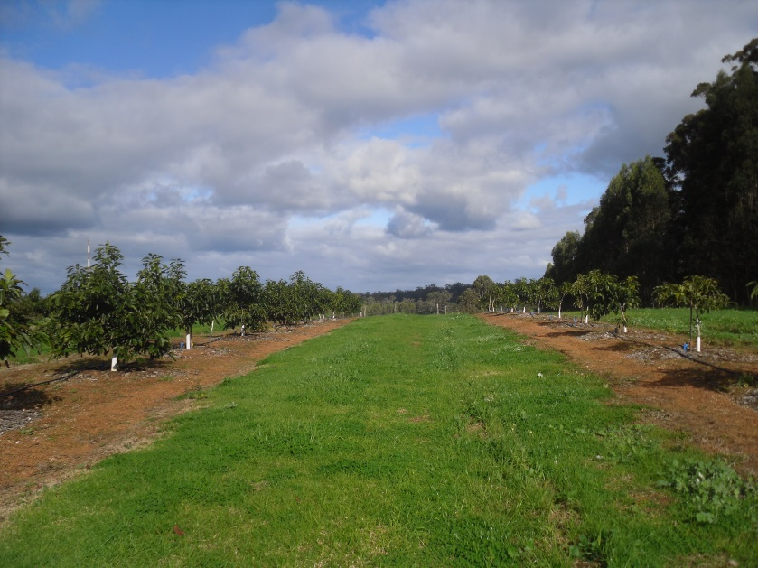
Treatment (left) and Control (right) rows of avocado - Soil Type 1

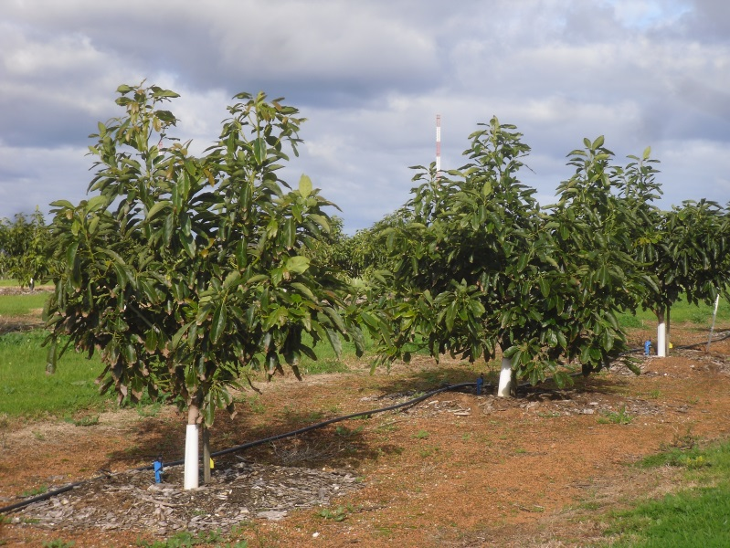
Treatment row - Soil Type 1

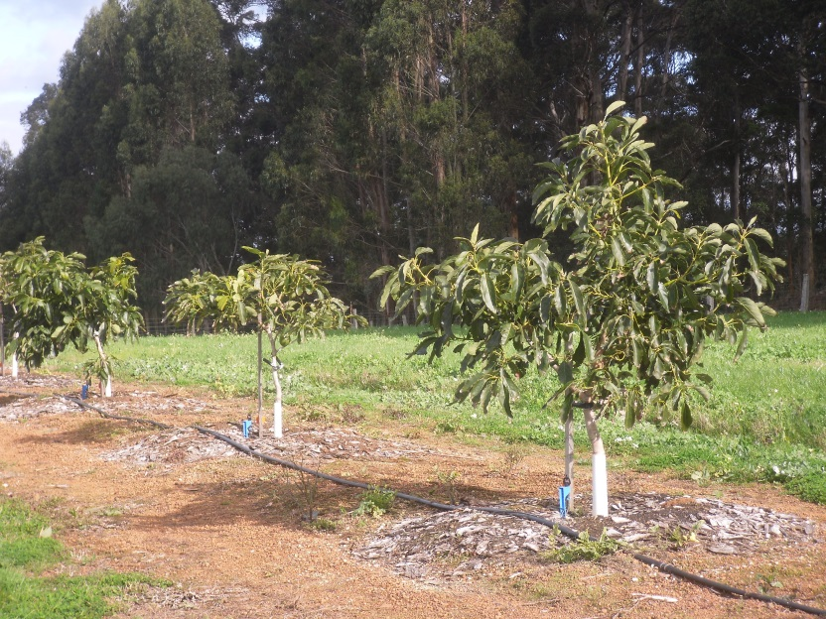
Control row - Soil Type 1
A random sample of leaf was collected from Trees #10. This is indicative only, more replicates need to be sampled.

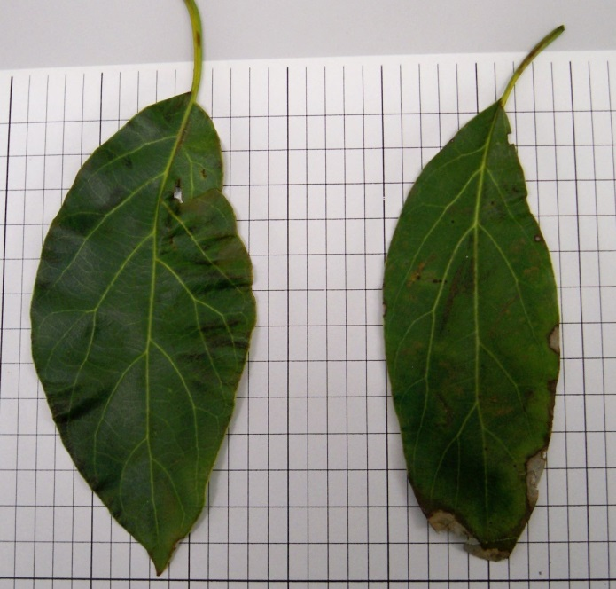
Both leaves are approximately the same length, the control leaf showing greater salt impact. This corresponds to tissue testing showing 23% less chloride in the treatment sample. The markedly larger size of the treatment leaf enables increased photosynthesis, leading to the faster growth and greater biomass of the trees grown in biochar amended soil.

Currently tests are being conducted by Prof Stephen Joseph (UNSW) and Lukas van Zweiten (DPINSW) on soil samples from the 0-10cm and 10-30cm zones of trees in each of the treatment blocks that do not have topical biochar-activated mulch applied. The results will shortly be presented in a paper funded by South West Catchments Council – a sample image below. We are requesting Lukas van Zweiten also test replicate samples from the control row with biochar-activated mulch to see whether (though may be too early to test) the biochar migrates through the soil profile via soil biology and transport with water. This would indicate the possibility of retrofitting existing avocado orchards in a cost-effective, if not immediately effective, manner. (See application extract point 11 above)

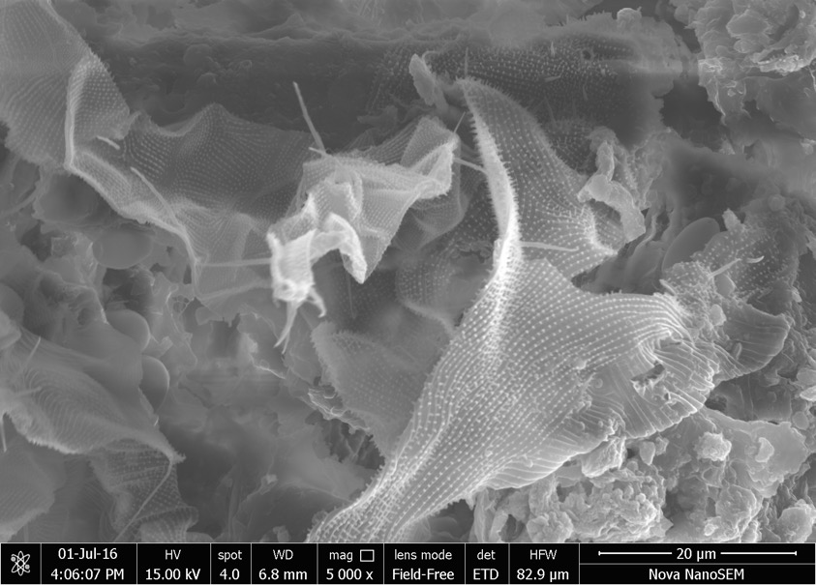
Probably Faunal Grazer on surface of the biochar around clusters of minerals

